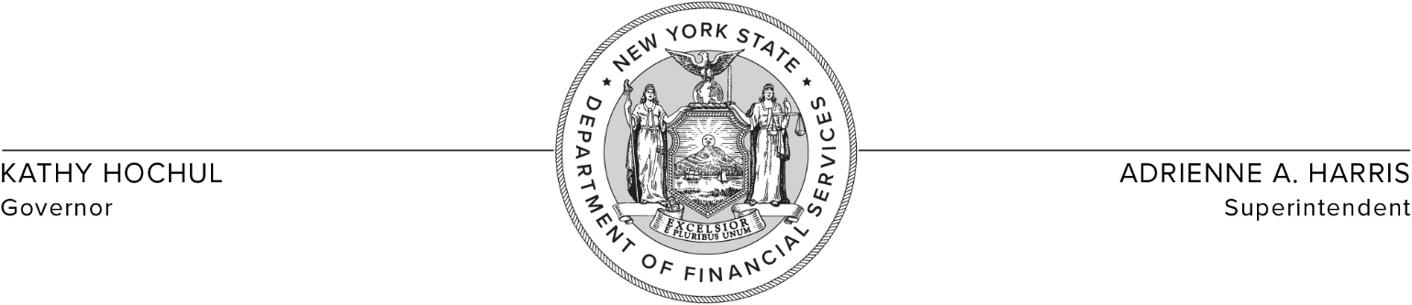
November 21, 2023

Actuarial Opinion Requirements for December 31, 2023 Reserves

The following directive applies to all life insurance companies and fraternal benefit societies doing business in New York and all insurers holding a certificate from the superintendent as being accredited for the reinsurance of life insurance, annuities, or accident and health insurance.

The Department is requiring that all New York State domestic companies which (a) are licensed in more than one state and are classified as Category A or Category B companies or (b) have admitted assets in excess of $100 million, submit a Statement of Actuarial Opinion based on Asset Adequacy Analysis for December 31, 2023 reserves, with additional reserves established as appropriate.

This directive affects all multi-state domestic life insurers and fraternal benefit societies which are classified as Category A and B companies and all life insurers, reinsurers, and fraternal benefit societies which are classified as Category C companies, as defined in Section 95.6 (b) of Regulation 126 and foregoes the exemption eligibility tests provided in Sections 95.6 (c)(1), (2), and (5) of Regulation 126.

New York-only licensed insurers which are classified as Category A and Category B companies may continue to submit a Statement of Actuarial Opinion Not Including Asset Adequacy Analysis, provided that the company meets the exemption eligibility tests set forth in Sections 95.6 (c)(1) or (2) of Regulation 126. Please note, the Department may require a company otherwise exempt to provide a Statement of Actuarial Opinion based on Asset Adequacy Analysis pursuant to Section 95.3(c) of Regulation 126.

Such submission is due on or before March 1, 2024.

